Name: Sneha Tiwari

Roll: 11500119052 | Group: B1

Assignment 8

**Assignment 1.**

A program to get some process related information’s,

Process ID of current process,

Process ID of parent process,

Real user ID of current process,

Effective user ID of current process,

Real group ID of current process,

Effective group ID of current process

**Solution:**

**C Program**

#include<stdio.h>

#include<stdlib.h>

#include<unistd.h>

#include<sys/types.h>

int main()

{

pid_t pid = getpid();

pid_t ppid = getppid();

pid_t ruid = getuid();

pid_t euid = geteuid();

pid_t rgid = getgid();

pid_t egid = getegid();

printf("PID of current process = %d\n",pid);

printf("PID of parent process = %d\n",ppid);

printf("Real user id of current process = %d\n",ruid);

printf("Effective user id of current process = %d\n",euid);

printf("Real group ID of current process = %d\n",rgid);

printf("Effective group id of current process = %d\n",egid);

return 0;

}

**Output**

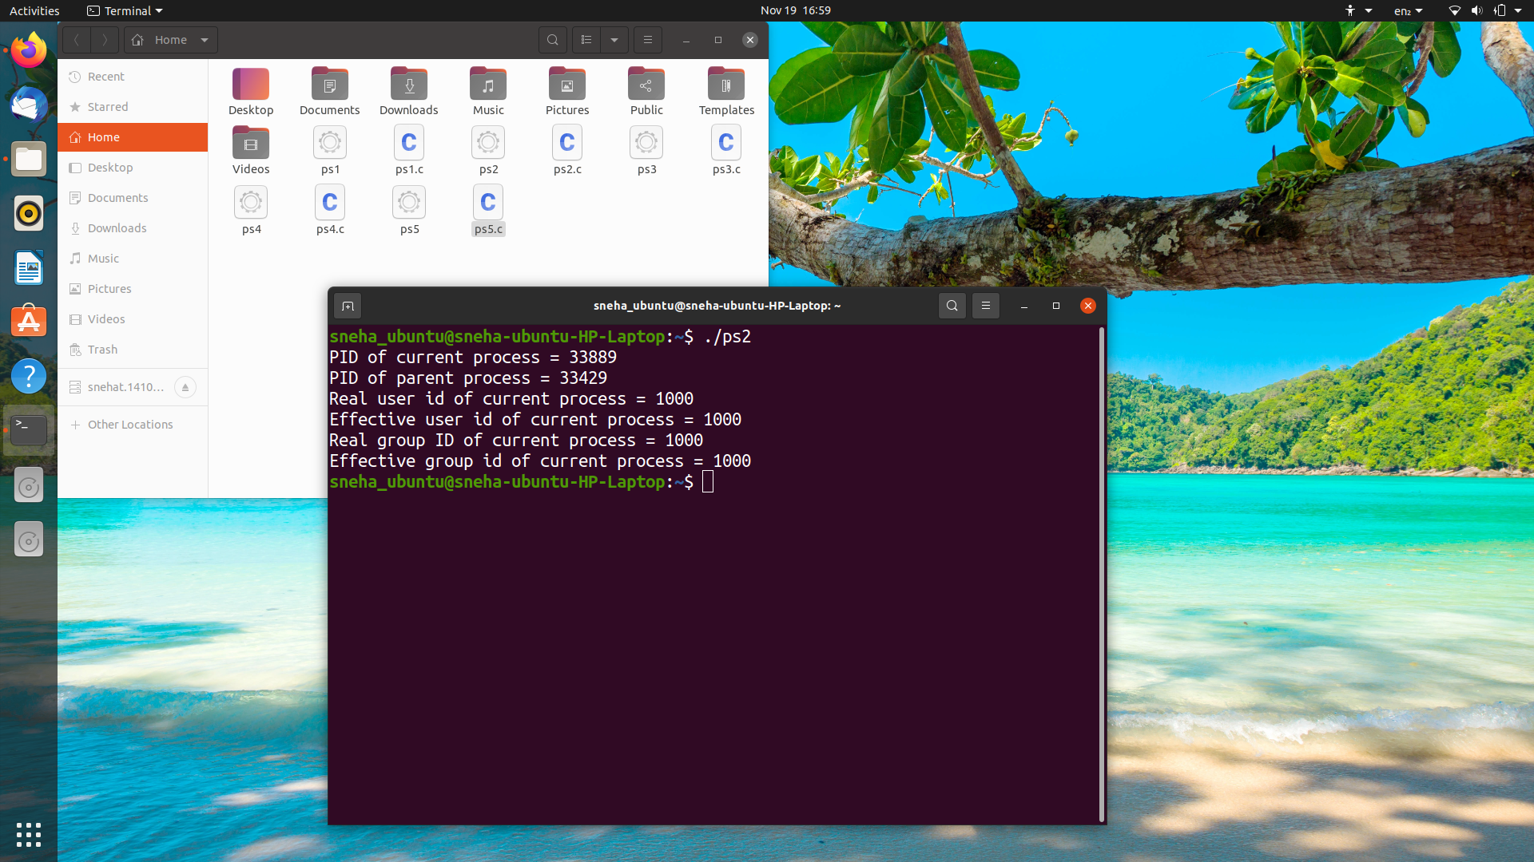

**Assignment 2.**

A program to create a child process.

**Solution:**

**C Program**

#include <stdio.h>

#include <sys/types.h>

#include <unistd.h>

int main()

{

    fork();

    printf("Hello world!\n");  // prints hello world twice as child process executes

                                // after its parent process

    return 0;

}

**Output**

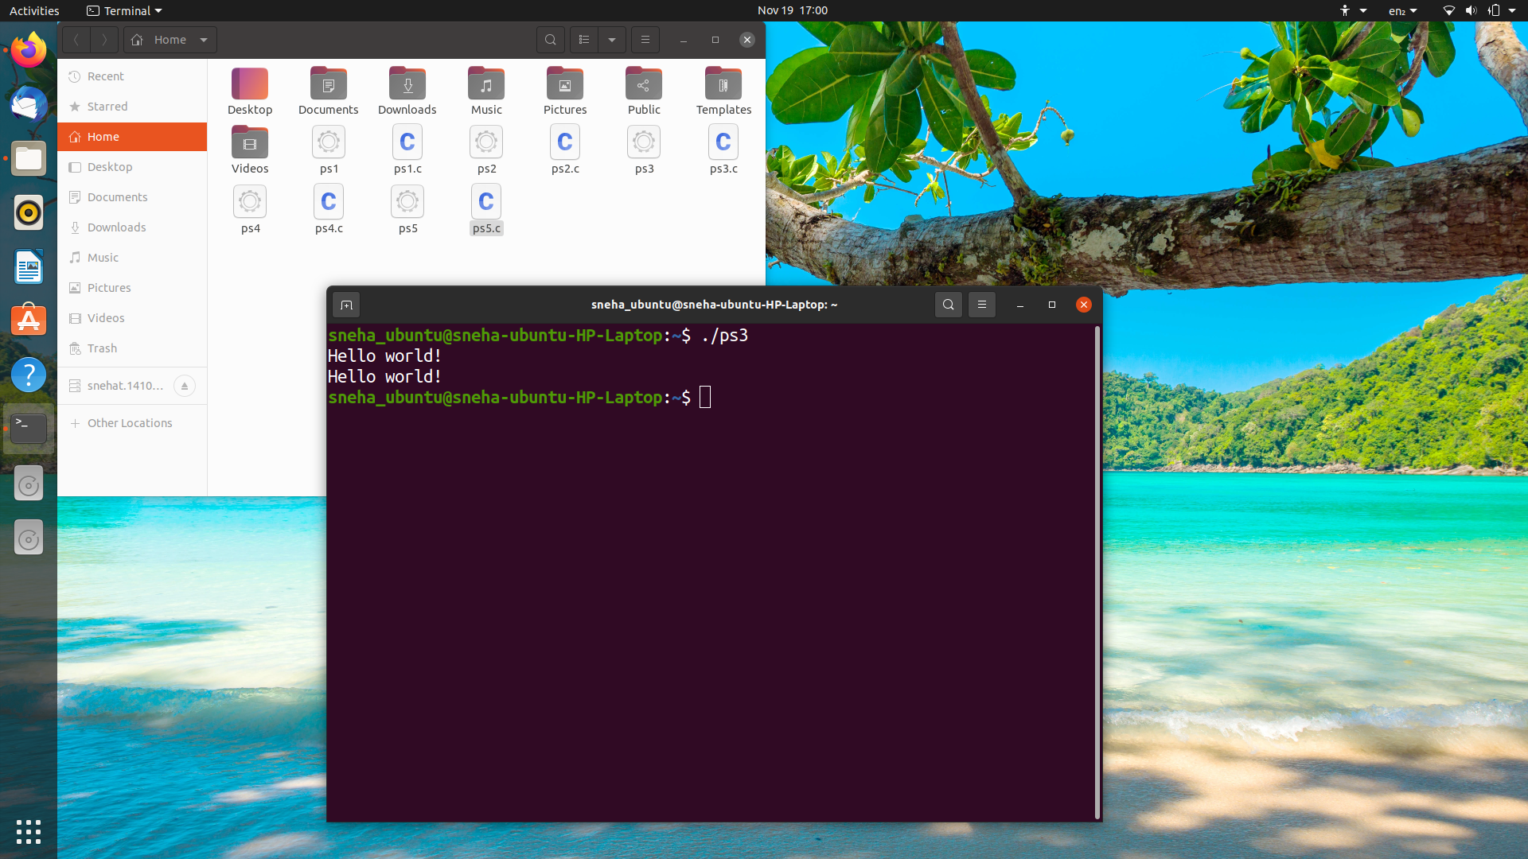

**Assignment 3.**

Write a C program to create a child process and allow the parent to display “parent process with process id” and the child to display “child process with its process id and its Parent process id ” on the screen.

**Solution:**

**C Program**

#include <stdio.h>

#include <stdlib.h>

#include <unistd.h>

int main() {

int pid = fork();

if (pid == 0) {

    printf("Hi, this is the child process! \nMy PID is = %d and my Parent ID is = %d.\n\n", getpid(), getppid());

}

else {

    printf("Hi, this is the parent process! \nMy PID is = %d and my Parent ID is = %d.\n\n", getpid(), pid);

}

return 0;

}

**Output**

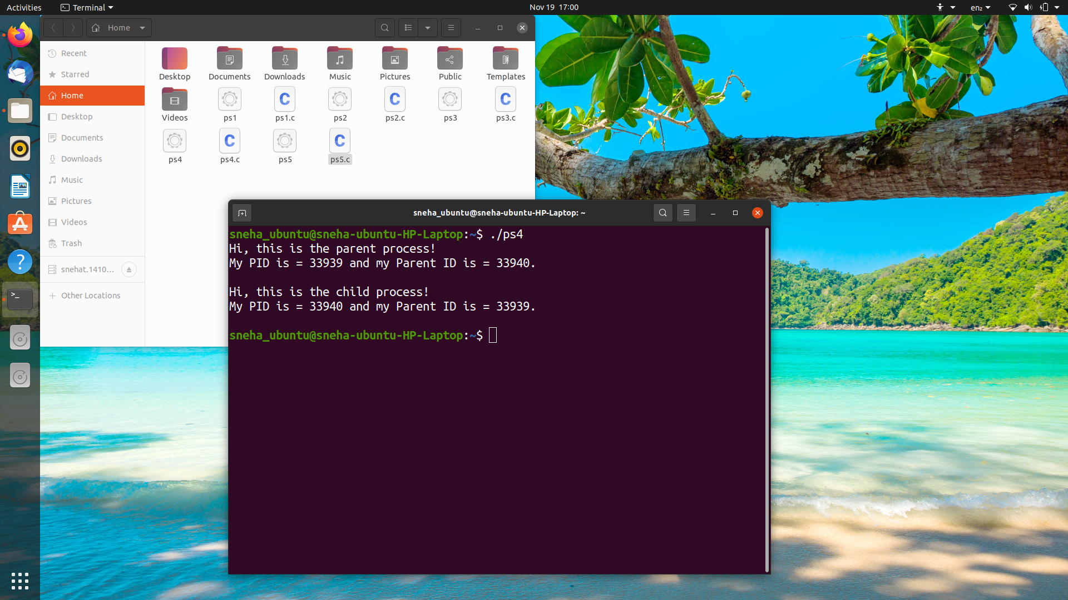

**Assignment 4.**

Program to create four processes (1 parent and 3 children) where they terminates in a sequence as follows:

(a) Parent process terminates at last

(b) First child terminates before parent and after second child.

(c) Second child terminates after last and before first child.

(d) Third child terminates first.

**Solution:**

**C Program**

#include<stdio.h>

#include<stdlib.h>

#include<unistd.h>

int main()

{

int pid, pid1, pid2;

pid = fork();

if (pid == 0) {

sleep(3);

printf("Child 1 => PID = %d and PPID = %d\n", getpid(), getppid());

}

else {

pid1 = fork();

if (pid1 == 0) {

sleep(2);

printf("Child 2 => PID = %d and PP = %d\n", getpid(), getppid());

}

else {

pid2 = fork();

if (pid2 == 0) {

printf("Child 3 => PID = %d and PP = %d\n", getpid(), getppid());

}

else {

sleep(3);

printf("Parent => PID = %d\n", getpid());

}

}

}

return 0;

}

**Output**



